How did Ancient Egyptians’ beliefs in Gods impact on their society?

Your task is to:

- Answer the following inquiry question: What part did Gods play in the life of Ancient Egyptians?

- Select one God to investigate. Create a minimum of 3 rich inquiry questions that will inform others about this Ancient Egyptian God.

- Hand draw a picture of your God.

- Present your research as a non-electronic visual display which includes:

- your discussion of the role of Gods in Ancient Egyptian society
- the answers to your inquiry questions
- your drawing

- Your visual display needs to be eye catching, well organised with appropriate headings, have a balanced layout and be carefully proofread.

Timeline: You will have 3 weeks to complete the task for homework
Due Date: Wednesday of Week 10 Term 3 (26 September)

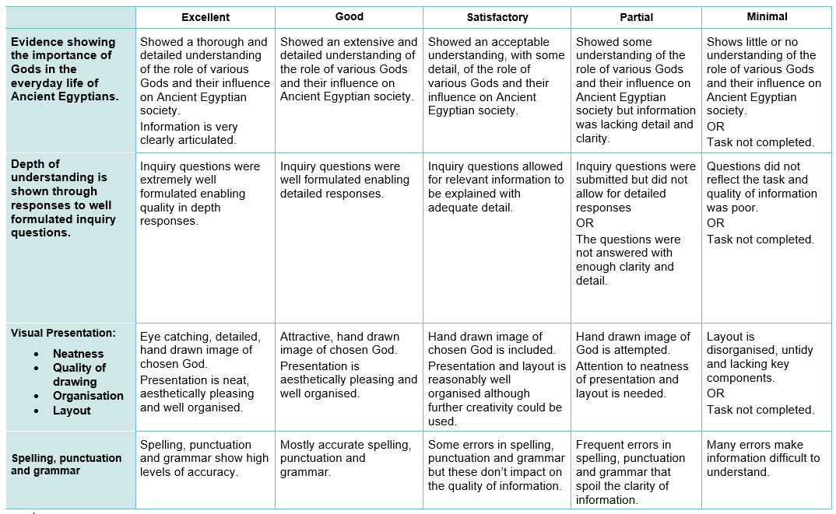
Success Criteria: Check what you will need to do to be successful.

